Experiment 5
Using Raptor – Draw and validate a flowchart for a given string of lower
case English alphabets. One can choose any two characters in the string
and replace all the occurrences of the first character with the second
character and replace all the occurrences of the second character with
the first character. Using Raptor draw and validate the flowchart
lexicographically smallest string that can be obtained by doing this
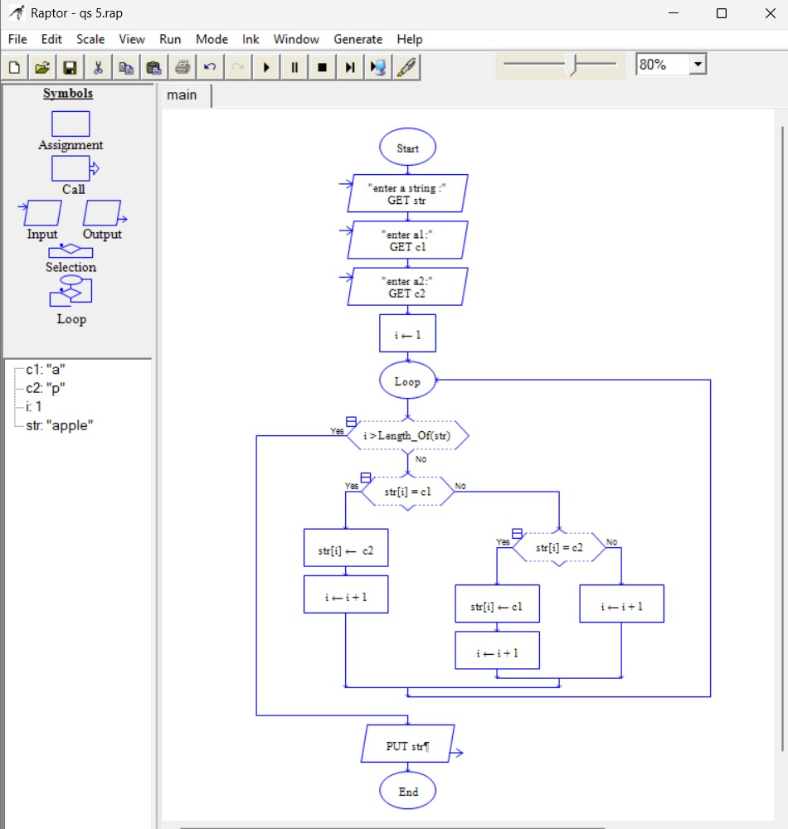
operation at most once.

